# PRACTICAL 1

**Write a program to implement common styles of image augmentation.**

# A. Random Image Warping Transformations

**Code :**

import cv2 as cv

import matplotlib.pyplot as plt import albumentations as A from skimage.io import imread def display_image(title, image):

plt.title(title) plt.imshow(image) plt.axis('off') plt.show()

imOriginal = cv.resize(imread("D:/Images_/kobi.png"),(0, 0), fx=2, fy=2).astype('float32')/ 255

display_image("Original Image",imOriginal) transform = A.Compose([

1. Affine( rotate=(-45, 45), scale=(0.8, 1.2),

translate_percent={'x': (-0.1, 0.1), 'y': (-0.1, 0.1)}, p=1.0

)

])

imAugmented = transform(image=imOriginal)['image'] display_image("Random Image Warping Transformation", imAugmented)

**Output:**

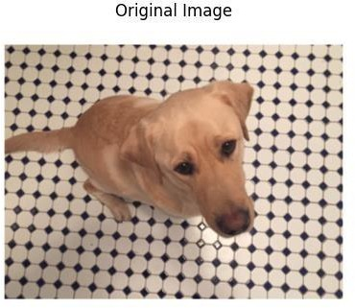 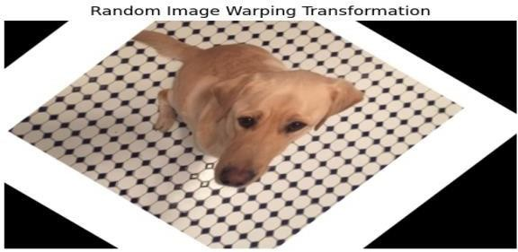

# Cropping Transformations

**Code:**

import cv2 as cv

import matplotlib.pyplot as plt from skimage.io import imread import numpy as np

import torchvision.transforms as T from PIL import Image

imOriginal =cv.resize(imread("D:/Images_/kobi.png"),(0, 0),

fx=2, fy=2).astype('float32')/ 255

imOriginal = Image.fromarray((imOriginal * 255).astype(np.uint8)) targetSize = (200, 100)

center_crop = T.CenterCrop(targetSize) imCenterCrop = center_crop(imOriginal) random_crop = T.RandomCrop(targetSize) imRandomCrop = random_crop(imOriginal) fig, axes = plt.subplots(1, 3, figsize=(15, 5)) axes[0].imshow(imOriginal) axes[0].set_title("Original Image") axes[0].axis('off') axes[1].imshow(imCenterCrop) axes[1].set_title("Center Crop") axes[1].axis('off') axes[2].imshow(imRandomCrop) axes[2].set_title("Random Crop") axes[2].axis('off')

plt.show()

**Output;**

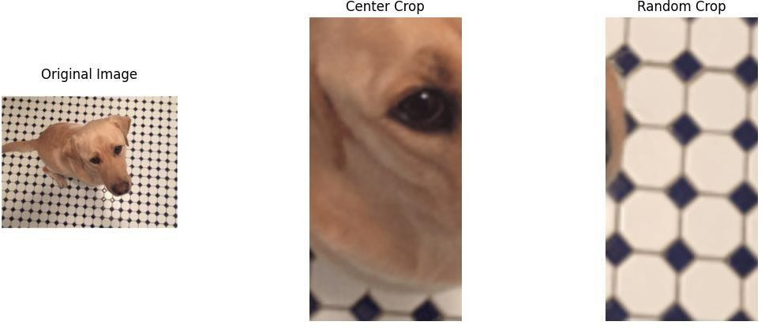

# Color Transformations

**Code :**

import cv2 as cv

import matplotlib.pyplot as plt from skimage.io import imread from torchvision import transforms from PIL import Image

import numpy as np

imOriginal = cv.resize(imread("D:/Images_/kobi.png"),(0, 0),fx=2, fy=2).astype('float32')/ 255 imOriginal = Image.fromarray((imOriginal * 255).astype(np.uint8))

def apply_color_jitter(image, brightness=0, contrast=0, saturation=0, hue=0): transform = transforms.ColorJitter(brightness=brightness, contrast=contrast,

saturation=saturation, hue=hue) jittered_image = transform(image) return jittered_image

imJittered = apply_color_jitter(imOriginal, hue=0.1) plt.figure(figsize=(10, 5))

plt.subplot(1, 2, 1) plt.imshow(imOriginal) plt.title('Original Image') plt.axis('off') plt.subplot(1, 2, 2) plt.imshow(imJittered)

plt.title('Hue Jittered Image') plt.axis('off')

plt.show()

imJittered = apply_color_jitter(imOriginal, saturation=0.5) plt.figure(figsize=(10, 5))

plt.subplot(1, 2, 1) plt.imshow(imJittered) plt.title('Saturation Jittered Image') plt.axis('off')

imJittered = apply_color_jitter(imOriginal, brightness=0.3) plt.subplot(1, 2, 2)

plt.imshow(imJittered) plt.title('Brightness Jittered Image') plt.axis('off')

plt.show()

imJittered = apply_color_jitter(imOriginal, contrast=0.5) plt.figure(figsize=(10, 5))

plt.subplot(1, 2, 1) plt.imshow(imJittered) plt.title('Contrast Jittered Image') plt.axis('off')

plt.show()

imGray = cv.cvtColor(np.array(imOriginal), cv.COLOR_RGB2GRAY).astype('float32') /255 contrastFactor = 1 - 0.2 * np.random.rand()

brightnessOffset = 0.3 * (np.random.rand() - 0.5)

imJittered = np.clip(imGray * contrastFactor + brightnessOffset, 0, 1) imJittered = (imJittered * 255).astype(np.uint8)

fig, axes = plt.subplots(1, 3, constrained_layout=True,figsize=(10, 5)) axes[0].imshow(imOriginal)

axes[0].set_title("Original Image") axes[0].axis('off') axes[1].imshow(imGray, cmap='gray') axes[1].set_title("Grayscale Image") axes[1].axis('off') axes[2].imshow(imJittered, cmap='gray')

axes[2].set_title("Jittered Grayscale Image") axes[2].axis('off')

plt.show()

**Output:**

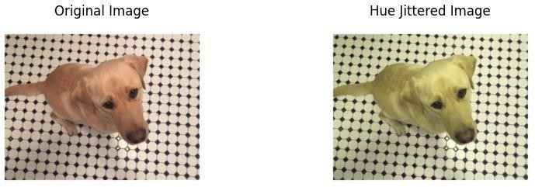

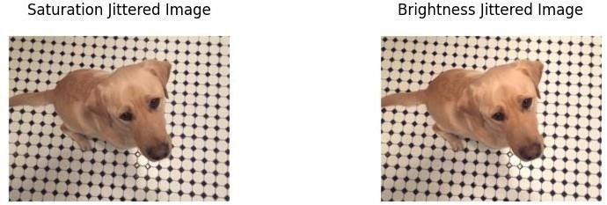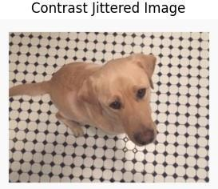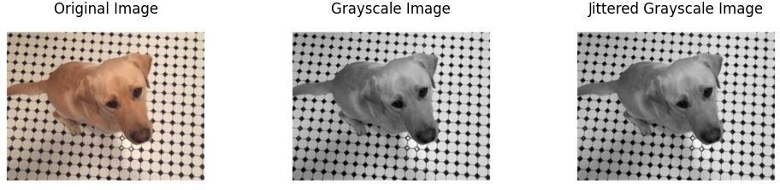

# Synthetic Noise

**Code:**

import cv2 as cv

import matplotlib.pyplot as plt from skimage.io import imread

from skimage.util import random_noise import numpy as np

imOriginal = cv.resize(imread("D:/Images_/kobi.png"),(0, 0),fx=2, fy=2).astype('float32')/ 255 imSaltAndPepperNoise = random_noise(imOriginal, mode='s&p', amount=0.1) imGaussianNoise = random_noise(imOriginal, mode='gaussian', var=0.01)

fig, axes = plt.subplots(1, 3, figsize=(25, 5)) axes[0].imshow(imOriginal) axes[0].set_title("Original Image") axes[0].axis('off') axes[1].imshow(imSaltAndPepperNoise) axes[1].set_title("Salt & Pepper Noise") axes[1].axis('off') axes[2].imshow(imGaussianNoise) axes[2].set_title("Gaussian Noise") axes[2].axis('off')

plt.show()

**Output:**

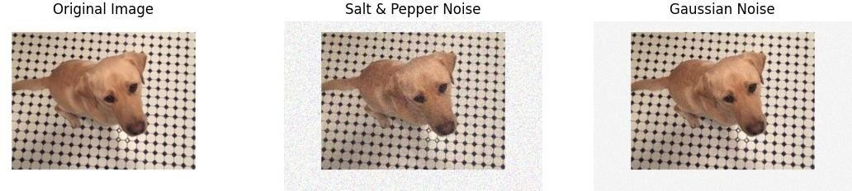

# Synthetic Blur

**Code:**

import cv2 as cv

import matplotlib.pyplot as plt from skimage.io import imread

from scipy.ndimage import gaussian_filter from PIL import Image

import numpy as np

imOriginal = cv.resize(imread("D:/Images_/kobi.png"),(0, 0),fx=2, fy=2).astype('float32')/ 255 imOriginal = (imOriginal * 255).astype(np.uint8)

sigma = 1 + 5 * np.random.rand()

imBlurred = gaussian_filter(imOriginal, sigma=(sigma, sigma, 0)) plt.figure(figsize=(10, 10))

plt.subplot(1, 2, 1) plt.imshow(imOriginal) plt.title('Original Image') plt.axis('off') plt.subplot(1, 2, 2) plt.imshow(imBlurred) plt.title('Blurred Image ') plt.axis('off')

plt.show()

**Output:**

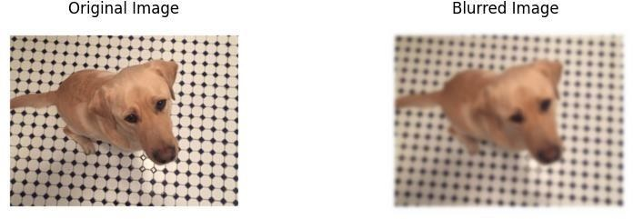

# `

**PRACTICAL 2**

# Write a program to Implement Pose estimation

**Code:**

import cv2 as cv import numpy as np

import matplotlib.pyplot as plt

input_image_path = "D:/Images -20240804T060317Z-001/Images_/person.jpg"

threshold = 0.2

inWidth = 368

inHeight = 368

BODY_PARTS = { "Nose": 0, "Neck": 1, "RShoulder": 2, "RElbow": 3, "RWrist": 4,

"LShoulder": 5, "LElbow": 6, "LWrist": 7, "RHip": 8, "RKnee": 9,

"RAnkle": 10, "LHip": 11, "LKnee": 12, "LAnkle": 13, "REye": 14,

"LEye": 15, "REar": 16, "LEar": 17, "Background": 18 }

POSE_PAIRS = [ ["Neck", "RShoulder"], ["Neck", "LShoulder"], ["RShoulder", "RElbow"],

["RElbow", "RWrist"], ["LShoulder", "LElbow"], ["LElbow", "LWrist"],

["Neck", "RHip"], ["RHip", "RKnee"], ["RKnee", "RAnkle"], ["Neck", "LHip"],

["LHip", "LKnee"], ["LKnee", "LAnkle"], ["Neck", "Nose"], ["Nose", "REye"],

["REye", "REar"], ["Nose", "LEye"], ["LEye", "LEar"] ]

net = cv.dnn.readNetFromTensorflow("D:/Images -20240804T060317Z- 001/Images_/graph_opt.pb")

frame = cv.imread(input_image_path) if frame is None:

raise ValueError(f"Image at path '{input_image_path}' could not be loaded.")

frameWidth = frame.shape[1] frameHeight = frame.shape[0]

net.setInput(cv.dnn.blobFromImage(frame, 1.0, (inWidth, inHeight), (127.5, 127.5, 127.5), swapRB=True, crop=False))

out = net.forward()

out = out[:, :19, :, :] # MobileNet output [1, 57, -1, -1], we only need the first 19 elements assert(len(BODY_PARTS) == out.shape[1])

points = []

for i in range(len(BODY_PARTS)): heatMap = out[0, i, :, :]

_, conf, _, point = cv.minMaxLoc(heatMap) x = (frameWidth * point[0]) / out.shape[3] y = (frameHeight * point[1]) / out.shape[2]

# Add a point if its confidence is higher than the threshold. points.append((int(x), int(y)) if conf > threshold else None)

for pair in POSE_PAIRS:

partFrom = pair[0] partTo = pair[1]

assert(partFrom in BODY_PARTS) assert(partTo in BODY_PARTS)

idFrom = BODY_PARTS[partFrom] idTo = BODY_PARTS[partTo]

if points[idFrom] and points[idTo]:

cv.line(frame, points[idFrom], points[idTo], (0, 255, 0), 3)

cv.ellipse(frame, points[idFrom], (3, 3), 0, 0, 360, (0, 0, 255), cv.FILLED)

cv.ellipse(frame, points[idTo], (3, 3), 0, 0, 360, (0, 0, 255), cv.FILLED) t, _ = net.getPerfProfile()

freq = cv.getTickFrequency() / 1000

cv.putText(frame, '%.2fms' % (t / freq), (10, 20), cv.FONT_HERSHEY_SIMPLEX, 0.5, (0,

0, 0))

frame_rgb = cv.cvtColor(frame, cv.COLOR_BGR2RGB) plt.imshow(frame_rgb)

plt.title('OpenPose using OpenCV') plt.axis('off')

plt.show()

**Output:**

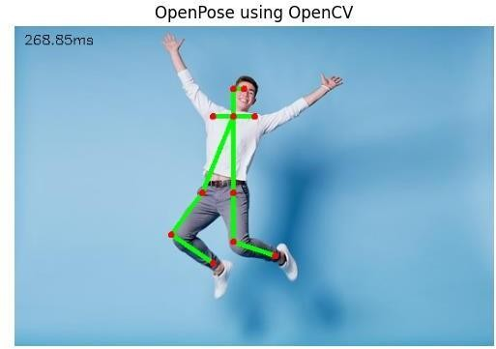

# PRACTICAL 3

**Write a program to Implement Feature Based Panoramic Image Stitching.**

**Code:**

import cv2

import matplotlib.pyplot as plt # Load images individually

image1 = cv2.imread('D:/Images -20240804T060317Z-001/Images_/data/001.jpg') image2 = cv2.imread('D:/Images -20240804T060317Z-001/Images_/data/002.jpg') image3 = cv2.imread('D:/Images -20240804T060317Z-001/Images_/data/003.jpg') image4 = cv2.imread('D:/Images -20240804T060317Z-001/Images_/data/004.jpg') image5 = cv2.imread('D:/Images -20240804T060317Z-001/Images_/data/005.jpg')

if image1 is None or image2 is None or image3 is None or image4 is None or image5 is None: print("One or more images not found")

else:

images = [image1, image2, image3, image4, image5] stitcher = cv2.Stitcher_create()

status, stitched = stitcher.stitch(images) if status == cv2.Stitcher_OK:

print("Stitching completed successfully.")

stitched_rgb = cv2.cvtColor(stitched, cv2.COLOR_BGR2RGB) plt.imshow(stitched_rgb)

plt.axis('off')

plt.show() cv2.imwrite('stitched_image.jpg', stitched)

else:

print(f"Stitching failed with status {status}.")

**Output:**

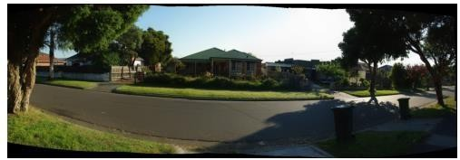

# PRACTICAL 4

**Write a program to Implement Image Blending techniques**

# Simple blending B) Weighted blending C) Mask blending

**Code:**

import cv2

from matplotlib import pyplot as plt from skimage.io import imread

image1 = cv2.resize(imread("D:\\Images -20240818T074730Z-001\\Images_\\forest.jpg"), (0,0), fx=2, fy=2).astype('float32') / 255

image2 = cv2.resize(imread("D:\\Images -20240818T074730Z-001\\Images_\\birds.jpg"), (0,0), fx=2, fy=2).astype('float32') / 255 image1=cv2.resize(image1,(image2.shape[1],image2.shape[0]))

plt.figure(figsize=(10,5)) plt.subplot(1, 2, 1)

plt.imshow(cv2.cvtColor(image1, cv2.COLOR_BGR2RGB)) plt.title('Image1')

plt.subplot(1, 2, 2)

plt.imshow(cv2.cvtColor(image2, cv2.COLOR_BGR2RGB)) plt.title('Image2')

plt.tight_layout() plt.show()

blended=cv2.add(image1,image2) plt.imshow(cv2.cvtColor(blended, cv2.COLOR_BGR2RGB)) plt.title("Simple Blended Image")

plt.show() alpha = 0.7

beta = 0.3

blended = cv2.addWeighted(image1, alpha, image2, beta, 0) plt.imshow(cv2.cvtColor(blended, cv2.COLOR_BGR2RGB)) plt.title("Weighted Blended Image")

plt.show()

mask = cv2.cvtColor(image2, cv2.COLOR_BGR2GRAY)

_, mask = cv2.threshold(mask, 1, 255, cv2.THRESH_BINARY) foreground = cv2.bitwise_and(image2, image2, mask=mask) background = cv2.bitwise_and(image1, image1, mask=mask) result = cv2.add(foreground, background)

plt.imshow(cv2.cvtColor(result, cv2.COLOR_BGR2RGB)) plt.title("Mask Blended Image")

plt.show()

Output:

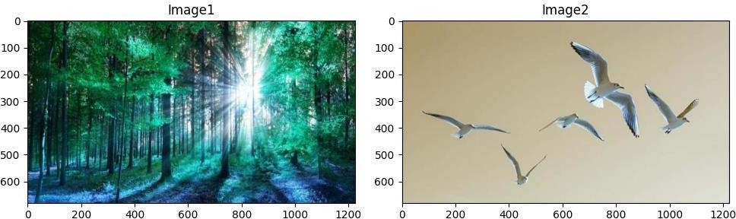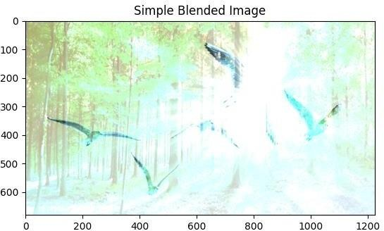

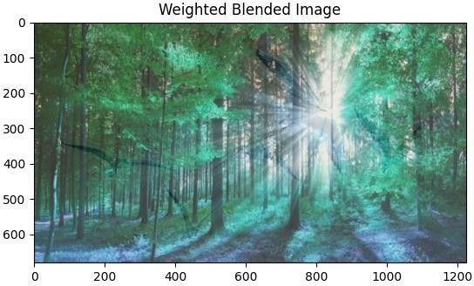

# PRACTICAL 5

**Write a program to Implement Image Compression.**

**Code:**

import cv2

from skimage.io import imread import os

import matplotlib.pyplot as plt

img = cv2.resize(imread("D:\\Images -20240818T074730Z-001\\Images_\\forest.jpg"), (0, 0), fx=2, fy=2).astype('float32') / 255 cv2.imwrite('lossless_compressed_image.png', img)

jpeg_quality = 90

cv2.imwrite('lossy_compressed_image.jpg', img, [cv2.IMWRITE_JPEG_QUALITY, jpeg_quality])

original_size = os.path.getsize('D:\\Images -20240818T074730Z-001\\Images_\\forest.jpg') lossless_size = os.path.getsize('lossless_compressed_image.png')

lossy_size = os.path.getsize('lossy_compressed_image.jpg') print(f'Original image size: {original_size} bytes') print(f'Lossless compressed image size: {lossless_size} bytes') print(f'Lossy compressed image size: {lossy_size} bytes')

lossless_img = cv2.resize(imread("lossless_compressed_image.png"), (0, 0), fx=2, fy=2).astype('float32')

lossy_img = cv2.resize(imread("lossy_compressed_image.jpg"), (0, 0), fx=2, fy=2).astype('float32')

plt.imshow(img) plt.title('Original Image') plt.show() plt.imshow(lossless_img)

plt.title('Lossless Compressed Image') plt.show()

plt.imshow(lossy_img) plt.title('Lossy Compressed Image') plt.show()

**Output:**

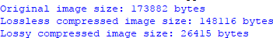

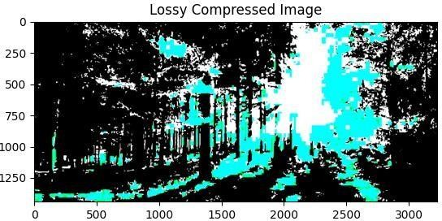

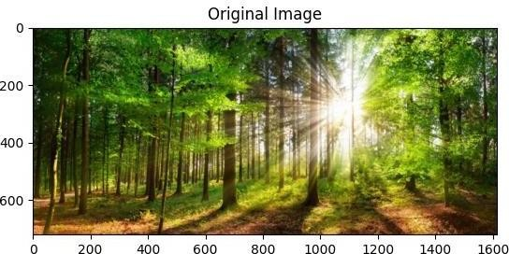

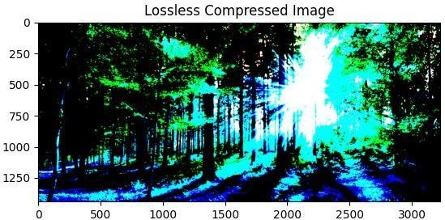

# PRACTICAL 6

**Write a program to Implement Image Matting technique.**

**Code:**

import cv2

import matplotlib.pyplot as plt import numpy as np

I = cv2.imread('D:\Matting-20240901T071408Z-001\Matting\matting1.png')

I=cv2.cvtColor(I,cv2.COLOR_BGR2RGB)/255 plt.imshow(I),plt.axis('off')

plt.show()

alpha_ex=cv2.imread('D:\Matting-20240901T071408Z- 001\Matting\matting2.png',cv2.IMREAD_GRAYSCALE)/255 plt.imshow(alpha_ex,cmap='gray'),plt.axis('off')

plt.show()

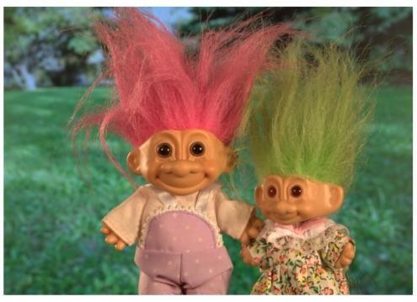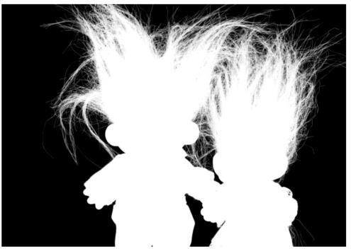

n_rows=I.shape[0] n_cols=I.shape[1] n_pixels=n_rows*n_cols I=np.reshape(I,(n_pixels,3)) I[:,0]=I[:,1]

I[:,2]=I[:,1]

alpha_ex=np.reshape(alpha_ex,(n_pixels,1)) G_B=1

I=alpha_ex*I+(1-alpha_ex)*[0,G_B,0] I = np.reshape(I, (n_rows, n_cols, 3)) plt.imshow(I), plt.axis('off') plt.show();

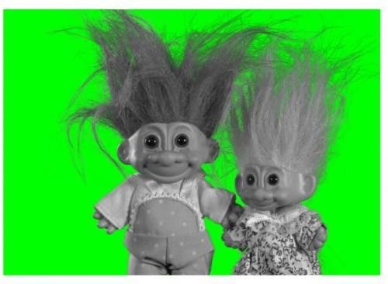

R_I = I[:, :, 0]

G_I = I[:, :, 1]

B_I = I[:, :, 2]

alpha = (R_I - (G_I - G_B))/G_B plt.imshow(alpha, cmap='gray'), plt.axis('off') plt.show();

alpha = np.reshape(alpha, (n_pixels, 1))

error = np.linalg.norm(alpha - alpha_ex)/np.linalg.norm(alpha_ex) print(f'Error (alpha): {error:.2e}')

K = cv2.imread('D:\\Matting-20240901T071408Z-001\\Matting\\bg.png') K = cv2.cvtColor(K, cv2.COLOR_BGR2RGB)/255

K = K[:n_rows, :n_cols, :]

plt.imshow(K), plt.axis('off') plt.show();

K = np.reshape(K, (n_pixels, 3)) R_I = np.reshape(R_I, (n_pixels, 1)) J = np.tile(R_I, 3) + (1 - alpha) * K

J = np.reshape(J, (n_rows, n_cols, 3)) plt.imshow(J), plt.axis('off') plt.show();

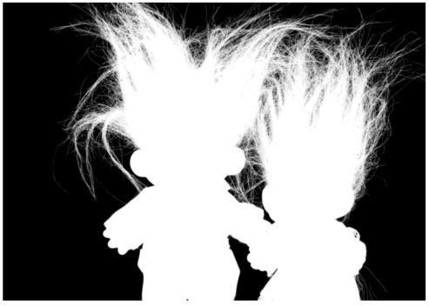

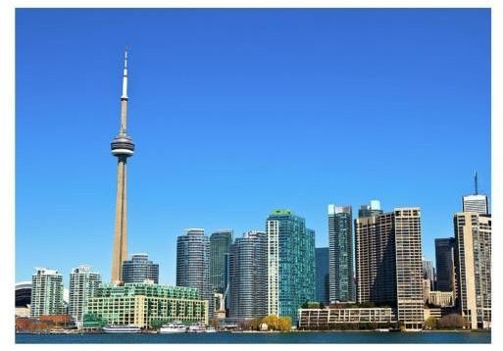

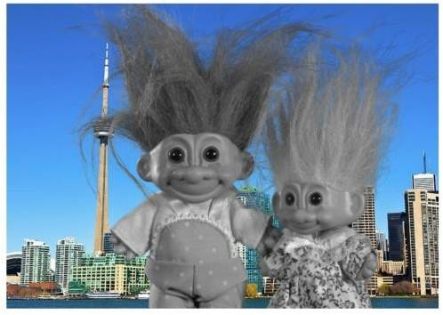

# PRACTICAL 7

**Write a program to Implement Texture analysis.**

**Code 1:**

import matplotlib.pyplot as plt

from skimage.feature import graycomatrix, graycoprops from skimage import data

PATCH_SIZE=21

image=data.camera()

grass_locations = [(280, 454), (342, 223), (444, 192), (455, 455)]

grass_patches = [image[loc[0]:loc[0] + PATCH_SIZE, loc[1]:loc[1] + PATCH_SIZE] for loc in grass_locations]

sky_locations = [(38, 34), (139, 28), (37, 437), (145, 379)]

sky_patches = [image[loc[0]:loc[0] + PATCH_SIZE, loc[1]:loc[1] + PATCH_SIZE] for loc in sky_locations]

xs=[]

ys=[]

for patch in grass_patches+sky_patches: glcm=graycomatrix(patch,distances=[5],angles=[0],levels=256,symmetric=True,normed=True) xs.append(graycoprops(glcm,'dissimilarity')[0,0]) ys.append(graycoprops(glcm,'correlation')[0,0])

fig=plt.figure(figsize=(8,8)) ax = fig.add_subplot(3, 2, 1)

ax.imshow(image, cmap=plt.cm.gray, vmin=0, vmax=255) for y, x in grass_locations:

ax.plot(x+PATCH_SIZE/2,y+PATCH_SIZE/2,'gs') for y,x in sky_locations:

ax.plot(x+PATCH_SIZE/2,y+PATCH_SIZE/2,'bs') ax.set_xlabel('Original Image')

ax.set_xticks([]) ax.set_yticks([]) ax.axis('image')

ax = fig.add_subplot(3, 2, 2)

ax.plot(xs[:len(grass_patches)], ys[:len(grass_patches)], 'go', label='Grass') ax.plot(xs[len(grass_patches):], ys[len(grass_patches):], 'bo', label='Sky') ax.set_xlabel('GLCM Dissimilarity')

ax.set_ylabel('GLCM Correlation') ax.legend()

for i,patch in enumerate(grass_patches):

ax = fig.add_subplot(3, len(grass_patches), len(grass_patches) * 1 + i + 1) ax.imshow(patch, cmap=plt.cm.gray, vmin=0, vmax=255) ax.set_xlabel(f"Grass {i + 1}")

for i, patch in enumerate(sky_patches):

ax = fig.add_subplot(3, len(sky_patches), len(sky_patches) * 2 + i + 1) ax.imshow(patch, cmap=plt.cm.gray, vmin=0, vmax=255) ax.set_xlabel(f"Sky {i + 1}")

fig.suptitle('Gray Level Co-occurrence Matrix Features', fontsize=14, y=1.05) plt.tight_layout()

plt.show()

**Output:**

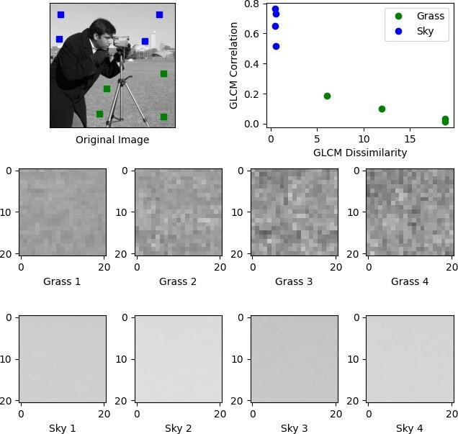

**Code 2:**

import seaborn as sns

from skimage.color import label2rgb import numpy as np

import matplotlib.pyplot as plt import h5py

slice_img = (h5py.File('C:/Users/Prakash/Downloads/test/mri_00041615.h5')['image'][100][:, :, 0]/3200*255).astype('uint8')

slice_mask = slice_img>0

fig, (ax1, ax2, ax3) = plt.subplots(1, 3, figsize=(11, 5)) ax1.imshow(slice_img, cmap='gray')

ax1.axis('off') ax1.set_title('Image')

ax2.imshow(slice_mask, cmap='gray') ax2.axis('off') ax2.set_title('Segmentation')

ax3.imshow(label2rgb(slice_mask > 0, slice_img, bg_label=0, )) ax3.axis('off')

ax3.set_title('Overlayed') plt.show()

**Output:**

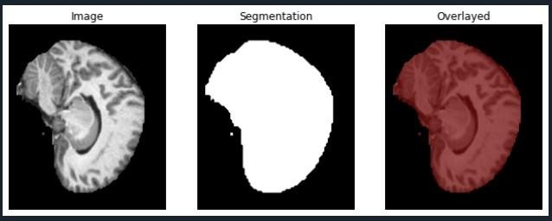

# PRACTICAL 8

**Write a program to Implement detect corner of an image using OpenCV.**

**Code:**

import numpy as np import cv2

from matplotlib import pyplot as plt

img=cv2.imread('D:\\Images -20240818T074730Z-001\\Images_\\corner.png') plt.title('IMAGE BEFORE CORNER DETECTION')

plt.imshow(img), plt.show()

gray = cv2.cvtColor(img, cv2.COLOR_BGR2GRAY) corners = cv2.goodFeaturesToTrack(gray, 27, 0.01, 10) corners = np.int0(corners)

for i in corners: x,y=i.ravel()

cv2.circle(img,(x,y),3,255,-1)

plt.title('IMAGE AFTER CORNER DETECTION')

plt.imshow(img),plt.show()

**Output:**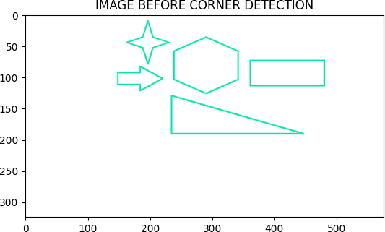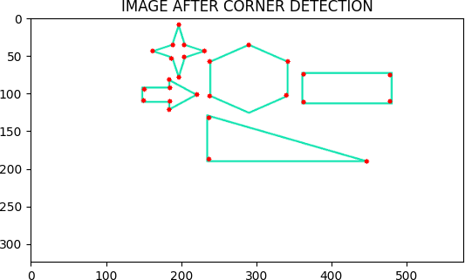

# PRACTICAL 9

1. **Write a program to Implement Vehicle detection using OpenCV Python.**

**Code:**

import cv2

car_cascade = cv2.CascadeClassifier('C:/Users/Prakash/Downloads/Images -20241020T073657Z- 001/Images/haarcascades/cars.xml')

def detect_vehicles(image_path):

img = cv2.imread(image_path)

gray = cv2.cvtColor(img, cv2.COLOR_BGR2GRAY)

cars = car_cascade.detectMultiScale(gray, scaleFactor=1.1, minNeighbors=5, minSize=(30, 30)) for (x, y, w, h) in cars:

cv2.rectangle(img, (x, y), (x + w, y + h), (0, 0, 255), 2) cv2.imshow('Vehicle Detection', img)

cv2.waitKey(0) cv2.destroyAllWindows()

image_path = 'C:/Users/Prakash/Downloads/Images -20241020T073657Z-001/Images/cars.jpeg' detect_vehicles(image_path)

**Output:**

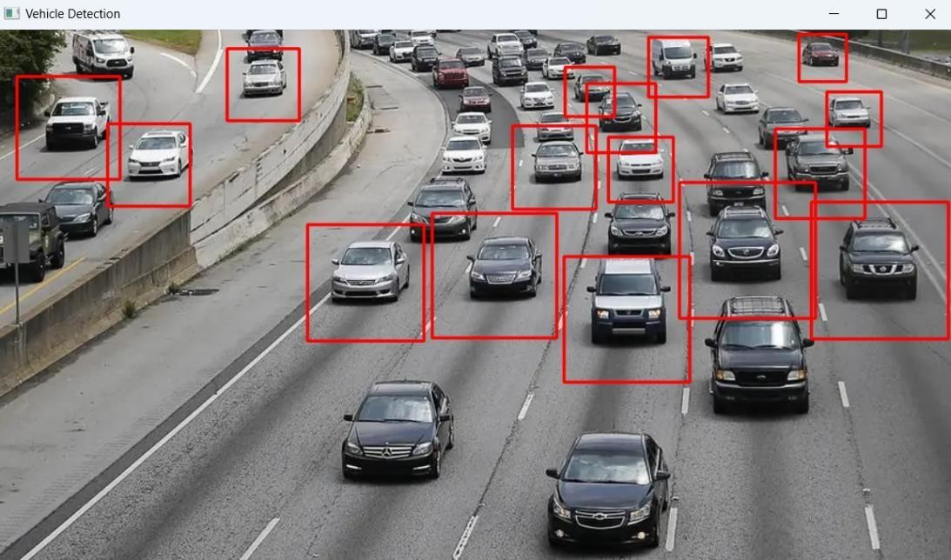

# License Plate Recognition with OpenCV and Tesseract OCR

**Code:**

import cv2

import matplotlib.pyplot as plt

haar_cascade = 'C:/Users/Prakash/Downloads/Images -20241020T073657Z- 001/Images/haarcascades/cars.xml'

video = 'C:/Users/Prakash/Downloads/Images -20241020T073657Z-001/Images/video.avi' cap = cv2.VideoCapture(video)

car_cascade = cv2.CascadeClassifier(haar_cascade) ret, frames = cap.read()

gray = cv2.cvtColor(frames, cv2.COLOR_BGR2GRAY)

cars = car_cascade.detectMultiScale(gray, 1.1, 1) for (x,y,w,h) in cars: cv2.rectangle(frames,(x,y),(x+w,y+h),(0,0,255),2) cv2.imshow('video', frames)

while True:

ret, frames = cap.read()

gray = cv2.cvtColor(frames, cv2.COLOR_BGR2GRAY) cars = car_cascade.detectMultiScale(gray, 1.1, 1)

for (x,y,w,h) in cars: cv2.rectangle(frames,(x,y),(x+w,y+h),(0,0,255),2)

cv2.imshow('video', frames) if cv2.waitKey(33) == 27:

break cv2.destroyAllWindows()

**Output:**

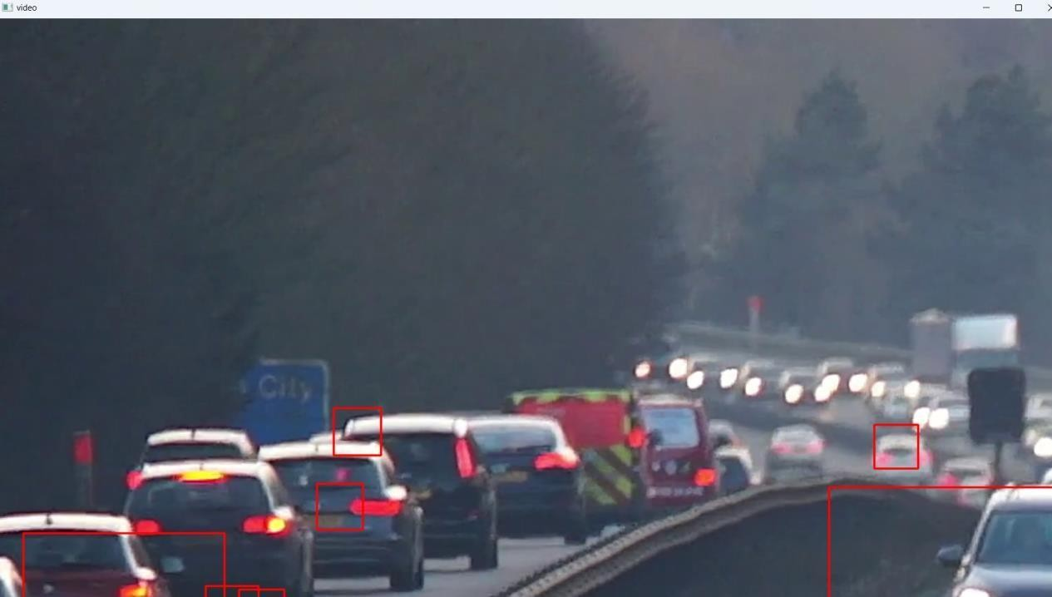

# PRACTICAL 10

**Write a program for Face Detection.**

**Code:**

import numpy as np import cv2

face_classifier=cv2.CascadeClassifier('D:\Images -20240818T074730Z- 001\Images_\haarcascades\haarcascade_frontalface_default.xml') eye_classifier = cv2.CascadeClassifier('D:\Images -20240818T074730Z- 001\Images_\haarcascades\haarcascade_eye.xml')

img = cv2.imread('D:\Images -20240818T074730Z-001\Images_\Sachin.jpeg') gray = cv2.cvtColor(img, cv2.COLOR_BGR2GRAY)

faces = face_classifier.detectMultiScale(gray, 1.05, 3) if faces is ():

print("No Face Found") for (x,y,w,h) in faces:

cv2.rectangle(img,(x,y),(x+w,y+h),(127,0,255),2) cv2.imshow('img',img)

cv2.waitKey(0)

roi_gray = gray[y:y+h, x:x+w] roi_color = img[y:y+h, x:x+w]

eyes = eye_classifier.detectMultiScale(roi_gray) for (ex,ey,ew,eh) in eyes:

cv2.rectangle(roi_color,(ex,ey),(ex+ew,ey+eh),(255,255,0),2) cv2.imshow('img',img)

cv2.waitKey(0) cv2.destroyAllWindows()

**Output:**

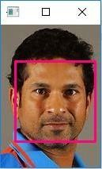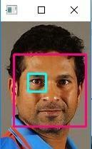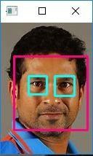

**Code :**

import cv2

img = cv2.imread('C:/Users/Prakash/Downloads/Images -20241020T073657Z- 001/Images/womens-cricket-team.jpg')

gray_img = cv2.cvtColor(img, cv2.COLOR_BGR2GRAY) # Loading the required haar-cascade xml classifier file

haar_cascade = cv2.CascadeClassifier('C:/Users/Prakash/Downloads/Images -20241020T073657Z- 001/Images/haarcascades/haarcascade_frontalface_default.xml')

faces_rect = haar_cascade.detectMultiScale(gray_img, 1.1, 9) for (x, y, w, h) in faces_rect:

cv2.rectangle(img, (x, y), (x+w, y+h), (0, 255, 0), 2)

cv2.imshow('Detected faces', img) cv2.waitKey(0)

**Output:**

